Introduction of Director Identification Numbers
From 1 November 2021 any new Directors of an Australian Company are required to obtain a Director Identification Number (‘Director ID’).

This measure forms part of the Government’s Modernising Business Registers program, which is designed to prevent the use of false or fraudulent Director identities. It also aims to improve the efficiency of the system, by making it easier to meet registration obligations and trace Director activity and relationships. By improving the integrity and security of business data it is expected to reduce the risk of unlawful activity.

The new requirement to obtain a Director ID also applies to individuals who are Directors of a Corporate Trustee for an SMSF.

A Director ID is a unique identifier that Directors need to apply for, like a Tax File Number. Where an individual is a Director of multiple companies, they are only required to have one Director ID that will be used across all companies.

A Director ID will remain with an individual forever - even if they change companies, resign altogether from any Director role(s), change names, or move overseas.
There are prescribed deadlines by which an individual must obtain a Director ID:
Date individual first becomes a Director | Date by when individual must have applied for a Director Identification Number
On or before 31 October 2021  (pre-existing Directors) | By 30 November 2022
Between 1 November 2021 and 4 April 2022 | Within 28 days of appointment as a Director
From 5 April 2022 | Before the individual is appointment as a Director
It is important to note that an application for a Director ID must be made by the individual acting as Director. The application cannot be completed by an agent or third party.

Applying for a Director Identification Number
There are 3 key steps for an individual to apply for a Director ID:
Step 1: Set up myGovID
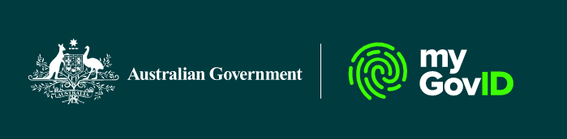
Individuals are required to have a myGovID set up before they can apply for a Director ID online. Information on how to setup a myGovID can be found by downloading the app at: https://www.mygovid.gov.au/set-up

Step 2: Gather documents
In applying, individuals will need to gather some information that the ATO already knows for identity verification. An individual’s tax file number, residential address held by the ATO, and information from two of the following documents is required:
- Bank account details
- ATO notice of assessment
- Super account details
- Dividend statement
- Centrelink payment summary
- PAYG payment summary
Please note that most of the above information can be downloaded from the individual’s myGov account. Therefore, it may be worthwhile for individuals to link this service ahead of applying for their Director ID.
NB. myGovID is different to an individual’s myGov account.

Step 3: Complete the Director ID application
Once the individual has a myGovID and information to verify their identity, they are ready to apply for a Director ID. This application process can be started using the link below (est. < 5 minutes):
https://abrs.gov.au/persons/ui/secure/start/applyForDirectorID?action=applyfordirectorid

How to apply if an individual cannot get a myGovID
If a person can’t get a myGovID with a Standard or Strong identity strength, the best way to apply for a director ID will depend on their situation.

Apply by phone:
An individual can apply by phone between 8:00am and 6:00pm Monday to Friday on 13 62 50.
An applicant will require:
- an Australian tax file number (TFN)
- information to verify their identity (as per step 2 above).

Apply with a paper form
If an individual can’t apply online or over the phone, they can apply using a downloadable form:

- Application for a director identification number (NAT75329, PDF, 306KB).

This is a slower process and requires certified copies of documents to verify an individual’s identity.

More information about Director IDs
Further information about the Director ID application process, and step-by-step instructions, can be found on the Australian Business Registry Services (ABRS) website:
https://www.abrs.gov.au/director-identification-number/apply-director-identification-number
Penalties
Please note that significant penalties apply where directors fail to comply with these new laws. The maximum penalties that can be applied are 60 penalty units (or $13,320) and 1 year imprisonment.

Additional breaches include if a director:
- Fails to comply with a direction from the Registrar
- Applies for multiple director ID’s
- Provides a false ID
- Misrepresents their ID
- Provides false or misleading information.

This fact sheet is current as of November 2021.

